## **requirement #1 –purpose column in payor form (3.2.7) screen**

**Payor Form –** Click on **View All Form** right sub tab on “**Manage** **Payor”** Screenthen Payor Form(s) List will display shown as below.

Purpose

Payor Form (Screen ID)

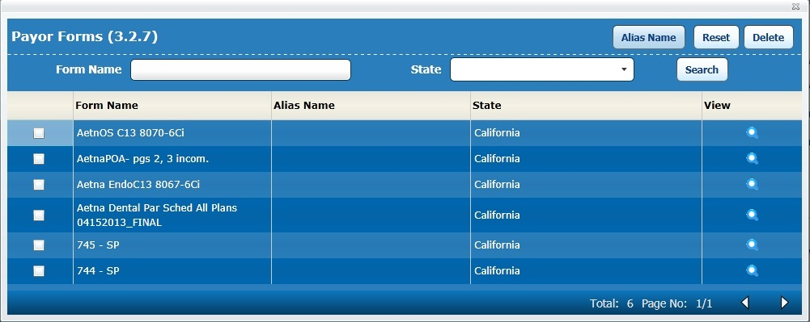**Payor Form-Screen**

Counter

* **Screen Name –** should be **Payor Form (Screen ID)** as shown in above screen.
* **Search Functionality –** No change
* **Action Buttons –** No change.
* **Grid Details –** will display following columns in grid.
  + **Check Box –** No change.
  + **Form Name –** No change.
  + **Alias Name –** No change.
  + **State –** No change.
  + **Purpose –** will facilitate to show purpose in column with correspond imported Payor form(s).
    - **Validation-** when user import the Payor form(s) from App Portal for a particular Payor then purpose should be import along with Payor form(s) and should display in column.
  + **View –** No change.

## **requirement #2 –logic for Update purpose list in form list**

**Form List–** Click on **View App** with selected provider in “**New Provider List/ Process In Provider”** Screenthen Payor “**Form** **List”** screen will display shown as below.

Form List (Screen ID)

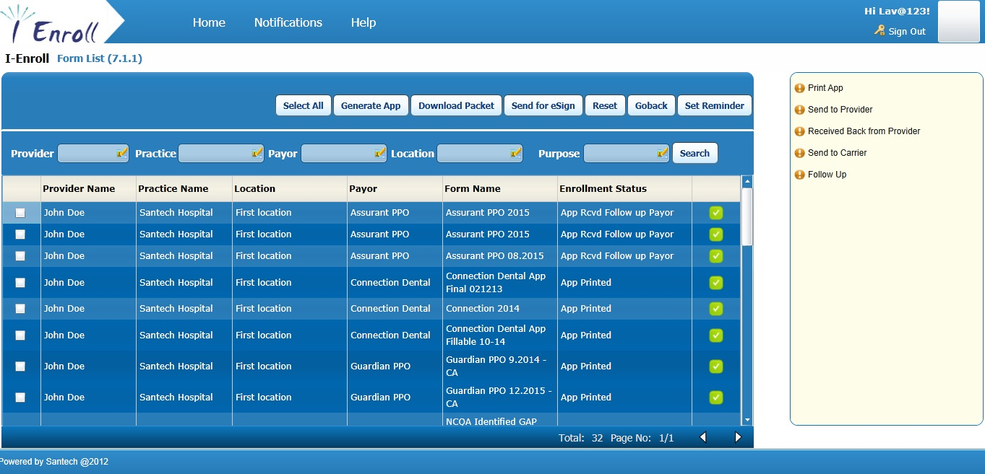**Form List-Screen**

Counter

* **Screen Name –** should be **Form List (Screen ID)** as shown in above screen.
* **Search Functionality –** 
  + **Provider –** No change.
  + **Practice –** No change.
  + **Payor –** No change.
  + **Location –** No change.
  + **Purpose –** will facilitate to select the purpose from Purpose List screen.
    - **Validation-** Click on LOV should display updated purpose list with all the purpose that have been imported in correspond of Payor form(s) **(refer Requirement #1)**.
* **Action Buttons –** No change.
* **Grid Details –** No change.